Managing the Security Risks inherent in Rapid or Agile System Development Processes.

White Paper
Napier Partners LLC

INF11109

40615561

December 2023

Word Count: 3107

Executive Summary
The purpose of this white paper is to outline the security risks that are associated with software development teams adopting an agile or rapid development approach to their systems development lifecycle.
Agile software development is a very popular way of developing software now days and is the preferred approach for almost all software development. A focus on the rapid release of working software in short time boxed iterations can lead to a shortfall in planning and architecture which can especially dangerous when applied to security.
The lack of security planning at the beginning of the SDLC can leave teams considering security issues as an afterthought or leaving them out entirely, resigning them to the technical debt pile. The issue for management when this happens is that they could become responsible for releasing software with severe security vulnerabilities.
Other practices that agile teams adopt, such as the increased use of third-party libraries included in the software that facilitate this rapid development can lead the teams to unwittingly include security vulnerabilities that have occurred downstream of the software supply chain. Evidence of high-profile supply chain attacks should provide ample warning to managers on the dangers of not implementing robust controls for detecting supply chain attacks.
Managers need to be aware of these issues and make sure the SDLC complies with the security policies set for the organization. Managers should consider adopting secure first agile methodologies that include security in every iteration and release. Managers should be aware that defining policies alone will not provide any real protection to the software itself.
This paper defines the issues facing managers in agile software development, providing ideas from research and news stories that aim to highlight the potential issues.

Table of Contents
Introduction 4
Context 5
Current Issues 6
Implications for Management 9
Conclusion 10
References 11

Introduction
Over the last decade or so software development teams from all industries have increasingly moved to a system development lifecycle (SDLC) that focuses on rapid development, including the introduction of agile methodologies. These agile or rapid development processes aim to deliver working software as quickly as possible, with the goal of gaining feedback from users and stakeholders in order to update the requirements of each iteration of the development cycle. This rapid feedback loop is core to the agile development process but can have an impact on security if not managed correctly.
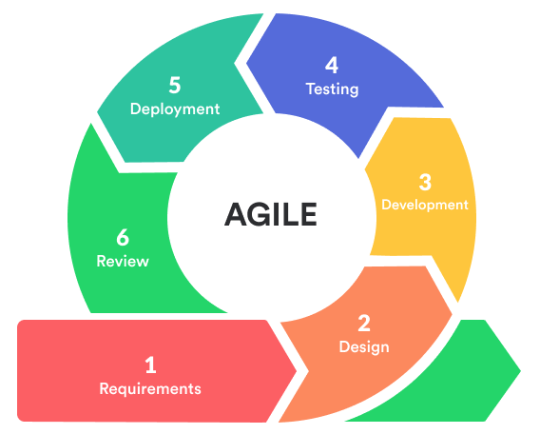
The focus on quickly producing working software means that security best practices can sometimes be left out or seen as non-essential to delivering the software. Often implementing security can be put off as technical debt and left as a task to implement before the product ships. Unfortunately, due to time constraints and deadlines this technical debt can sometimes be overlooked.
Figure 1 - Agile Development Process

This means that it can be easy for software development teams to introduce security vulnerabilities into their software which subsequently lead to software shipping with significant security issues. Security vulnerabilities should be taken into consideration during each iteration of the SDLC and need to be seen as a core requirement to finishing an iteration. Automation can be put in place during the build process to highlight any known security issues and feed that back to the developers to fix the software before it is allowed to be deployed.
The nature of rapid software development means that developers rely heavily on third party libraries to deliver their software in a timely manner. These third-party libraries may also have security vulnerabilities, which may result in developers unwittingly introducing security vulnerabilities into their own software. Security vulnerabilities in the software supply chain is a big issue and we will go into more detail later in the paper.
The practice of DevOps has come about to solve some of these issues, specifically around automation. Non-functional security requirements can be embedded into the DevOps process and can provide software development teams with rapid feedback on security issues.
The goal of this white paper is to highlight the specific issues that can arise from not managing security risks within the software development process and how security companies like Napier Partners LLC can help address these issues by providing recommendations based on research from the industry.

Context
In a report from the company Digital.ai (2021) it is mentioned that Agile adoption for software development teams grew from 37% in 2020 to 86% in 2021.
Agile software development has been wrapped up in many different methodologies over the years with names like Scrum, XP, Kanban, DSDM and many more. The key concepts of an Agile SDLC comes from the original Manifesto for Agile Software Development (2001). These concepts are “Individuals and interactions over processes and tools”, “working software over comprehensive, documentation”, “customer collaboration over contract negotiation” and “responding to change over following a plan”. The principle relating to working software over comprehensive documentation can sometimes be taken to mean no documentation at all. This can cause an issue specifically related to non-functional security requirements. As noted by Behutiye, W et al (2022), documentation is less prioritized and quality requirements such as security are often underspecified in agile software development.
One methodology based on the Agile Manifesto is the Scrum methodology which typically breaks the process down into time boxed iterations of two to four weeks, called sprints. These time boxed sprints can cause an issue when it comes to managing security risk in software and this issue is outlined in detail in the current issues section. (Include Citation)
According to Herr, T et al (2020) software supply chain attacks have been steadily increasing since 2010. The most well-known and largest attack of this kind was the SolarWinds attack in which attackers compromised the SolarWinds Orion software which was widely used inside large organizations all over the world.
Software supply chain attacks come about from the need to incorporate third party libraries and software into our systems so that we can leverage software written by others to fulfil a part of a system requirements. This facilitates rapid software development by allowing developers to stand on the shoulders of other developers who have already solved well known development problems and wrapped them up into handy downloadable libraries. Ecosystems and package management sites have emerged that seek to make this extremely easy for developers. The risk that needs to be managed is how do you trust these third-party libraries? Who is a trusted source and how do we know which libraries may have security vulnerabilities? The good news is there are ways to mitigate this with good security policies and automation. Software supply chain attacks are a category of threat that is increasingly becoming more popular. Supply chain attacks involve an attacked introducing malicious code into a third-party package, library or trust application. An organization who trusts the source of this application or library can unwittingly introduce the malicious code into their own software or IT infrastructure.
In traditional models of software development operational practices such as building and deploying code, testing and quality assurance has been the responsibility of IT teams dedicated to these tasks. This caused a disconnect between the developers and the deployment of their code and developer teams found that reliance of a separate department to get their code deployed and important feedback was hindering the quality and reliability of their software. This runs counter to the quick feedback loop at the core of agile software development.
Over time as processes and tools matured there was a so called “shift left” of these operational tasks into the development team. Automation of software deployments became an ever-increasing pattern, and this movement was eventually named DevOps. As Chrostof Ebert et. al (2016) remark “Quality deliveries with short cycle time need a high degree of automation.” Leonardo Leite et al. (2019) In their survey of DevOps concepts and challenges mention that one of the two pillars of DevOps is automation. This shows that automation is a key practice that system development teams need to embrace form a security perspective because with this automation comes the ability for teams to automate security testing of their applications. Each release of the software can be tested against known vulnerability databases which improves the management of security risks by allowing development teams to easily get a picture of their overall security posture. Consultancies such a Napier Partners LLC can help with setting up this automation and integrating the myriad of tools and processes into current software development practices.

Current Issues

  - Lack of security planning and architecture in agile methodologies
Scrum is an agile methodology that focuses on fast iterations and can result in a lack of planning up front in the so-called sprint 0 phase. In their paper on secure scrum Pohl, C., & Hof, H.-J. (2015). talk about how this lack of planning can mean that security design decisions will often be left to the implementation phase of an iteration resulting in a lack of consistent, detailed security architecture from the start. Security should be at the core of every iteration and release cycle, and not seen as a hinderance to the delivery of software. As discussed by BasuMallick. C (2021) in an article discussing security during sprint planning the question is asked whether product owners need to prioritize security during sprint planning with the benefit of creating a secure code base from scratch. This falls to management to define the responsibility of stakeholder during agile software development.
  - Time boxed sprints
The core principles of the Agile Manifesto have been embedded into the different methodologies over time and one key practice that has emerged from this is the practice of time boxed “sprints”. These time boxed sprints tend to be from two to four weeks like and the idea is to produce a list of working software features at the end of the sprint.
An issue arises from time boxed sprints in that short development time means that nonfunctional requirements such as security often get left out, pushed to a new sprint or simply not considered as it doesn’t directly contribute to working software.
We can address this issue by automating the build and deployment process and embedding a security step that runs static and dynamic analysis of the code to assess the security posture of the running application and highlight any security issues that need to be dealt with. Overall, this process means the team will produce more bug free and vulnerability free software to its stakeholders.
  - DevOps and automation of security.
Y. Valdés-Rodríguez et al (2023) talk about the traditional response to a company defending against security issues has been to standardize their security posture using policies and guidelines such as NIST, ISO27001 and COBIT. This adherence to security best practices improves the overall security posture of the company but does little to improve the security of the actual software itself. By not checking the software itself for construction issues that include vulnerabilities in the software, a company is never sure how well their software will hold up to attacks.
Non-functional security requirements need to be included in the software development lifecycle and specific tests need to be included to prove that the system isn’t vulnerable to known security attacks (Y. Valdés-Rodríguez et al. 2023). DevOps plays a large role here in that automation of security test gives the developers immediate feedback on the security posture of the software. Iterative agile software development practices also play a role in making sure that the non-functional security requirements are met on every iteration.
  - Supply chain security bugs.
The recent attacks of Solar Winds and NotPetya (Greenberg 2022) highlight the devastation that supply chain attacks can render to organizations. Supply chain attacks have been on the increase in recent years prompting the NCSC to issue guidance on dealing with them NCSC (2022). The malware associated with these high profile attacks was delivered through third-party software that was compromised using the software dependency supply chain. An example of a supply chain attack is shown in figure 2.
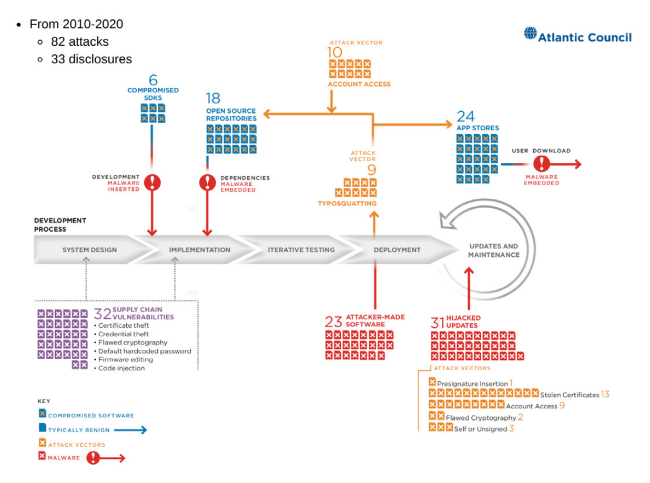
Figure 2- Example of a supply chain attack (Atlantic Council 2020)
Software developers would not be able to write complex software without reusing shared libraries from other developers. This means taking dependencies on a third-party library downloaded from a library feed. The inherent nature of rapid software development and the focus on delivering software in short iterations means that developers are further incentivized to re-use third party software to decrease their workload.
There are several library feeds such as NuGet for Microsoft .NET, NPM for JavaScript and many others. The problem with these shared feeds is that it is hard for the feed maintainer to make sure all libraries uploaded are secure and do not contain malicious code. Rouge npm packages are being found all the time (The Hacker News 2023). If a package gets compromised it’s hard for a developer to know until it’s too late. Libraries also need updating frequently to deal with any new vulnerabilities that arise, there can be a fine line between trusting the source and including the update, while also making sure that the new update doesn’t contain malicious code. The fact that even small software applications can include hundreds of third party libraries means that often libraries are not updated to the latest version, resulting in security vulnerabilities going unnoticed.
There are a few mitigations to this issue that organizations can implement and security companies like Napier Partners can help with. The first mitigation is creating a robust dependency policy within the software development lifecycle. The policy needs to state that dependencies should be scanned and vetted before being included in code. The policy should also state which downstream library feeds are trusted and which are not.
The next mitigation is to have a private library feed where only known, scanned dependencies are stored, and company software can only use this feed for dependencies.
The final mitigation is the use of automation tools in the DevOps process to make sure every code release is scanned by a vulnerability scanner which will search dependencies against known vulnerability databases, highlighting ones that have been compromised.

Implications for Management
Management of the SDLC is the responsibility of number of roles in the organization. The first is the role of the lead software developer who typically designs and implements the technical aspect of the SDLC. The lead developer typically reports to a Development Manager or the CTO but it is the responsibility of the CTO, IT managers and CISO to formulate a security policy that covers the issues described. The responsibility of the lead software developer is to implement the technical aspects of the policy. Some organizations have a separate DevOps team that is responsible for the automation of the security policy into the SDLC.
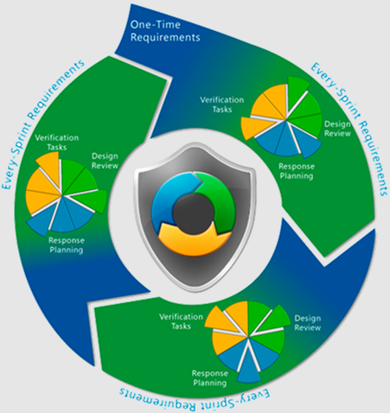
An organization should implement governance in the form of published security guidelines and policies to give software development teams a standard to work towards when building their systems. These guidelines and policies can be based on established frameworks such as ISO27001, NIST and COBIT. For example, NIST have a publication for supply chain risk management practices (NIST SP 800-161r1. 2022) that management can use to implement in their own risk management documents.
Managers need to consider whether to base the organizations SDLC on a standard such as the Microsoft SDL-Agile methodology (Microsoft 2012) which brings security requirements to the forefront of the SDLC, instead of an afterthought. The Microsoft SDL is a set of guidelines for secure software development and Microsoft propose “every-sprint requirements” which means that SDL requirements are included in every iteration of the development and security requirements must be met before releasing any software. Microsoft also propose automation of these security tasks.
Figure 3 - Microsoft (2012) Agile SDL
Management is also responsible for setting the standard for quality requirements that are implemented in each iteration of the SDLC. It should be clear what quality requirements relating to security need to be built into each iteration and what quality gates should control the release of software. This would avoid the issue of having a lack of security architecture at the beginning of a project and focusing solely on the functioning software.
Compliance is also an issue with the supply chain of dependencies in software as it is hard to understand the risk imposed by including third parties in the software development lifecycle. Standards that include a Software Bill of Materials for each software are becoming popular among open-source software such as the Linux operating system. The Linux foundation include guidance on Software Bill of Materials (SBOM) (Linux Foundation. 2022) that can help management build their own SBOM solution into the software they use.
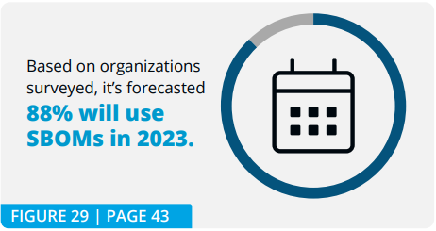
Managers should consult with compliance and risk management teams and have a method of quantifying the risk software imposes on the organization as a way of confirming compliance. Practices such as SBOM, automated vulnerability scanning and quality gates help the organization understand the impact on security the software might have.
Figure 4 - Linux Foundation (2022)

Conclusion
The need for rapid software development in today’s world has spawned a new breed of agile software development methodologies that moves away from the traditional design up front waterfall methods that was prevalent in the early days of systems development and still prevails today in some areas such as critical systems.
The principle of the agile manifesto lays the foundation for today’s agile methodologies. Although the principles drive a more iterative and rapid software development lifecycle where early feedback is the order of the day, this does not always result in positives, and can have some drawbacks. Some teams take the principle of working software over comprehensive documentation as a queue to produce no design or documentation up front when beginning a project. This can lead to non-functional requirements that do not result in features being neglected or left out entirely. Non-functional security requirements should be embedded into the SDLC and become part of every iteration in the development process.
Managers need to be aware of these non-functional security requirements and make sure they create robust security policies that feed down into the SDLC and become part of the development process.
DevOps as a movement in software development came about with the need to automate parts of the software development process, and this is where non-functional security requirements should be embedded into the process. For instance, automation of vulnerability scanning on every release or build of the software making sure every piece of working code meets the organizations security policy. Managers should embrace the DevOps movement and either build an in-house team, train developers to understand and use DevOps principles and tools or use third party consultants to make sure the software development team is able to focus on developing features, while ensuring non-functional security requirements are taken care of.
As software gets more complex and time-boxed iterations in agile methodologies became more prevalent, developers increasingly turned to incorporating third-party libraries to their software. There exists numerous package managers and library feeds for every programming language and framework. It is hard for the package manager hosts to scan every library for security vulnerabilities and this has led the way for to a class of threat called a supply chain attack.
Every organization in the world incorporates third party software into their environment but managers need to be aware of how security vulnerabilities can bypass their traditional security controls and provide back-doors for attackers to exploit. There are some high-profile cases of this happening that resulted in ransomware, costing the organizations, millions of pounds to rectify. Managers need to provide security policies and guidance to development teams to set the expectations on the use of package managers and third-party libraries. Some mitigations include using private feeds with vetted third-party libraries and only allowing developers to include packages from this feed. Another mitigation is the concept of a software bill of materials (SBOM) that allows organizations to understand exactly where each component of a third-party application came from and what security vulnerabilities might be present.
As software gets more complex and the need for rapid software development increases to keep up with the changing demands of todays business world, managers need to be aware of the implications of attempting to release software without the necessary security controls in place. The threat landscape of attacks has become increasingly sophisticated, and attackers will seek to exploit the lack of security controls put in place when an organization is rushing to release software that has not been checked for vulnerabilities.

References
Digital.ai (2021). 15Th State of Agile Report. https://info.digital.ai/rs/981-LQX-968/images/SOA15.pdf?_ga=2.2071153.1396698264.1663000131-2013811604.1663000131
Kent Beck et al. (2001). Manifesto for Agile Software Development. https://agilemanifesto.org/
S. Bartsch, "Practitioners' Perspectives on Security in Agile Development," 2011 Sixth International Conference on Availability, Reliability and Security, Vienna, Austria, 2011, pp. 479-484, doi: 10.1109/ARES.2011.82.
Ebert, C., Gallardo, G., Hernantes, J., & Serrano, N. (2016). DevOps. IEEE Software, 33(3), 94–100. https://doi.org/10.1109/MS.2016.68
Yolanda Valdés-Rodríguez, Jorge Hochstetter-Diez, Jaime Díaz-Arancibia, & Rodrigo Cadena-Martínez. (2023). Towards the Integration of Security Practices in Agile Software Development: A Systematic Mapping Review. Applied Sciences, 13(4578), 4578-. https://doi.org/10.3390/app13074578
Pohl, C., & Hof, H.-J. (2015). Secure Scrum: Development of Secure Software with Scrum. ArXiv.Org. https://doi.org/10.48550/arxiv.1507.02992
Behutiye, W., Rodríguez, P., Oivo, M., Aaramaa, S., Partanen, J., & Abhervé, A. (2022). Towards optimal quality requirement documentation in agile software development: A multiple case study. The Journal of Systems and Software, 183, 111112-. https://doi.org/10.1016/j.jss.2021.111112

Herr, T., Lee, J., Loomis, W., Scott, S., 2020. Breaking trust: shades of crisis across an insecure software supply chain. Technical Report. https://www.atlanticcouncil. org/wp-content/uploads/2020/07/Breaking-trust-Shades-of-crisis-across-aninsecure-software-supply-chain.pdf .

Greenberg, A. (2022). The Untold Story of NotPetya, the Most Devastating Cyberattack in History https://www.wired.com/story/notpetya-cyberattack-ukraine-russia-code-crashed-the-world/

The Hacker News (2023). Rogue npm Package Deploys Open-Source Rootkit in New Supply Chain Attack. https://thehackernews.com/2023/10/rogue-npm-package-deploys-open-source.html

NIST SP 800-161r1. (2022). Cybersecurity Supply Chain Risk Management Practices for Systems and Organizations. https://nvlpubs.nist.gov/nistpubs/SpecialPublications/NIST.SP.800-161r1.pdf
Linux Foundation. (2022). Software Bill of Materials (SBOM) and Cybersecurity Readiness https://8112310.fs1.hubspotusercontent-na1.net/hubfs/8112310/LF%20Research/State%20of%20Software%20Bill%20of%20Materials%20-%20Report.pdf
Microsoft. (2012). SDL-Agile Requirements. https://learn.microsoft.com/en-us/previous-versions/windows/desktop/ee790620(v=msdn.10)
BasuMallick. C (2021). Should Product Owners Prioritize Security During Sprint Planning? https://www.spiceworks.com/it-security/application-security/articles/sprint-planning-security-concerns/
NCSC. (2022). NCSC issues fresh guidance following recent rise in supply chain cyber attacks. https://www.ncsc.gov.uk/news/ncsc-issues-fresh-guidance-following-recent-rise-in-supply-chain-cyber-attacks

